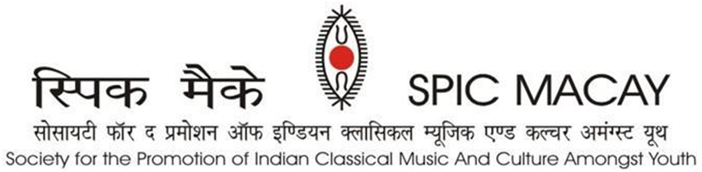

**Press release Day 4 – May 23, 2024**

**Melodious tunes of Vidhushi Jayanthi Kumaresh and Pt. Ulhas Kashalkar**

IITM, Chennai: SPIC MACAY’S 9th International Convention continued its tradition of providing ashram like setting to participants. The fourth day began at *brahmamuhurat (3.30 am).* Through hatha and naad yog,participants delved deeper into the inward journey. Gurbani and meditation enhanced the spiritual experience. *Nishkam Seva* has been SPIC MACAY's foundation and strength. To stress upon its significance, shramdaan has been a vital component of all its programs. At convention, the participants daily devote specific time for shramdaan and inculcate the spirit of seva.

After holistic breakfast, participants immersed themselves into 3-hour morning workshops and intensives consisting of Carnatic Vocal by Vidwan Neyveli Santhanagopalan, Gurbani by Dr Alankar Singh, Sattriya by Guru Gopiram Burha Bhakat, Kathak by Vid. Sunayana Hazarilal, Mohiniyattam by Dr Neena Prasad, Odissi by Vidushi Madhavi Mudgal, Pung Cholom by Khumukcham Romendro Singh, Purulia Chhau by Shri Tarapada Rajak, Hatha Yog by Swami Tyagrajanand Saraswati, Puppetry by Sudeep Gupta, Dhrupad by Ustad Wasifuddin Dagar.

They had wide ranging craft intensives to choose and experience, such as the Tikuli painting (Bihar) by Shri Ashok Kumar Biswas, Gond Tribal painting (Madhya Pradesh) by Shri Bhajju Shyam, Mughal Miniature painting (Rajasthan) by Janab Shakir Ali, Roghan art (Gujarat) by Janab Abdul Gafur Khatri, Mask making (Majuli Assam) by Shri Hemchandra and Terracotta (Tamil Nadu) by Shri VK Munusamy. Holistic lunch was followed by 45 minutes of guided Yog Nidra experience, after which participants experienced relaxed minds, and felt mindful.

The afternoon started with Singhi Cham by **Shri Chabilal Pradhan**. Singhi Chham or Kanchendzonga Dance is a lion dance form from Sikkim, where the dancers perform in a lion costume that represents the snow lion. The audience had a thrilling experience. It was followed by a Purulia Chhau performance by **Shri Tarapada Rajak**. The accompanists are Prashanta Mahato, Niranjan Sahis, Pitambar Mahato,Sadhu mahato, Amrit Bouri, Kirtan Bagdi, Ambarish Mahato, Amit Bouri, Kartik Sahis, Bishnu Sahis,Rahul Mahato, Goutam Sahis, Dipak Karmarkar, Sukumar Sahis and Parasuram Mahato.  **Vidushi Parvathy Baul** (SNA Awardee), an exponent of Baul Sangeet, which is a traditional Bengali folk music, enchanted the audience.

Holistic dinner was followed by a Saraswati Veena performance by **Vidushi Jayanthi Kumaresh** (SNA awardee) accompanied by Jayachandra Rao (Mridangam) and Trichy Krishnaswamy (Ghatam). Her tunes were melodious, clear and vibrant. The final concert of the day was Hindustani Vocal by Padmashri **Pandit Ulhas Kashalkar**. He was accompanied by Suresh Talwalkar on Tabla, Pravin Kaslikar on Harmonium , Adwait Keshar (Vocal) and Nirbhay Saxena (Vocal).His concert was emotional and powerful.

This week-long international convention from **20th May to 26th May** was attended by a total of 1300 delegates and will feature **70 performances** and a total of **33 intensives** which include classical music, dance, yog as well as crafts by renowned maestros of our country. The main supporter of the convention is Tata Consultancy Services.

**ABOUT SPIC MACAY**

SPIC MACAY is a 45-year-old volunteer-based, apolitical, non-profit organization working to bring Indian classical music, dance and other aspects of our culture like folk arts, meditation, yoga, cinema screenings, talks by eminent persons, heritage walks and crafts workshops to university and school students. We are striving to enrich the quality of formal education among adolescents and youth by raising awareness about various aspects of Indian heritage and motivating them to imbibe the values contained therein. Volunteers from all walks of life organize about 5000 programmes every year in 100 towns of India and abroad. During the pandemic, SPIC MACAY organized 1000 programmes Online.

***Our Supporters:*** *TCS, Incredible India, Ministry of Culture, Govt. of India, Ministry of Tourism, Govt. of Uttar Pradesh, Ministry of Tourism, Govt. of Assam, NEZCC, The Hindu, Publico, DD, Times of India, DanikJagran, SRF Foundation, Ministry of Education, Govt. of India, Ministry of Culture, Govt. of India, DMI Housing Finance, Lal Family Foundation, Anand Bajaj Foundation, Turner Morrison Foundation, Takshilla, SIFF, Polaris Foundation. Individual Supporters: Yogesh Andley, Ashwini Sharma, Dinesh Vasudeva and Arun Jain.*

For more queries, please contact:

|  |  |  |
| --- | --- | --- |
| **Suman Doonga**  National Vice Chairperson  9899308093  suman.doonga@spicmacay.com | **Jayashree Kannan**  Convention Convenor  98418 16134 | **Anshuman Jain**  Media Coordinator  9810000874  anshumanjain@gmail.com |