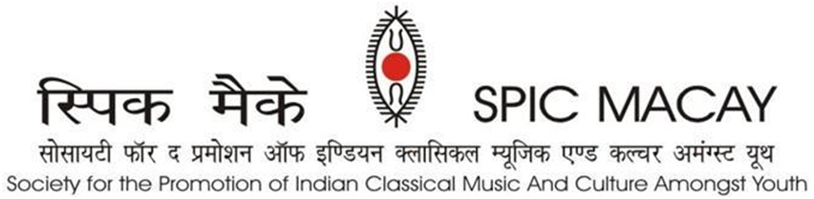

**Press release May 20 – 23, 2024**

**IITM, Chennai:** The formal ceremony of SPIC MACAY 9th internal convention at IITM was inaugurated on May 20, 2024 by Maestro Isaignani Ilaiyaraaja (Padma Vibushan). The evening was graced by chief guests, the Governor of Tripura, Shri. Indrasena Reddy Nallu, Maestro Isaignani Ilaiyaraaja**,** and IITM director Shri Kamakoti Veezhinathan. Padma Vibhushan Shri. Ilayaraja also inaugurated **IITM-Maestro Ilaiyaraaja centre for Music Learning and Research.** The session started with a morning performance by Vidwan **Seshampatti Sivalingam** (Padma Shri)**,** renowned Nadaswaram artist and *asthana vidwan* of Sri Kanchi Kamakotipeetam. The evening ceremony had bharatnatyam performance of Vidushi **Padma Subrahmanyam** (Padma Vibhushan)and flute concert of **Dr.Pt Hariprasad Chaurasia** (Padma Vibhushan).

Day 2 of SPIC MACAY started at 4 am with various intensives like Hath yoga and *Nada* yoga as well as Gurbani/meditation sessions under the guidance of eminent gurus such as Ustad F Wasifuddin Dagar, Vidwan Malladi Suri Babu, Kalamandalam Sugandhi, Pt. Ritwik Sanyal, Dr Alankar Singh, Swami Tyagrajanand Saraswati, Swami Tejomayanand Saraswati, Brahmakumaris Sister Manisha. Later, the students participated in the different intensive workshops like Carnatic and Hindustani vocal, Dhrupad, Gurbani, Sattriya, Bharatanatyam, Kuchipudi, Kathak, Mohiniyattam, Odissi, Kathakali, Pung cholam, Purulia chhau, Theatre, Singhi Cham, Hatha yoga, puppetry, Tikuli painting, Gond Art, Mughal miniature painting, Roghan art, Mask making, Terracotta, and meditation.  The afternoon session had Kabir Gayan by **Shri Kaluram Bamaniya**, Padmashri awardee, followed by a talk by **Shri Damodar Mauzo (bhai)** (Jnanpith Awardee). Evening concerts began with melodious Carnatic Violin performance by **Padmashri Vidushi A.Kanyakumari** and concluded with a splendid Kathak performance by **Vidushi Sunayana Hazarilal.**

Third day continued with the rigorous intensive workshops. Participants gained deep insights of our rich cultural heritage through wide ranging craft intensives such as Tikuli painting (Bihar) by Shri Ashok Kumar Biswas, Gond Tribal painting (Madhya Pradesh) by Shri Bhajju Shyam, Mughal Miniature painting (Rajasthan) by Janab Shakir Ali, Roghan art (Gujarat) by Janab Abdul Gafur Khatri, Mask making (Majuli Assam) by Shri Hemchandra, Terracotta (Tamil Nadu) by Shri VK Munusamy. During afternoon the audience enjoyed the Doll’s theatre show by Shri Sudip Gupta (SNA Awardee). It was followed by Habib Tanvir’s Naya Theatre group who presented a play titled ‘Charandas Chor’. The delegates witnessed the exhilarating concerts of Lalgudi GJR Krishnan and Nevyeli Santhana Gopalan. The concerts were mesmerizing.

SPIC MACAYs fourth day (May 23,2024) continued the tradition of waking up at brahmamuhurth doing rigorous yoga and intensive classes followed by ‘Shramdan’. The afternoon sessions had wonderful performance of Singhi Chham by **Shri Chabilal Pradhan** and team. This was followed by amazing Purulia Chhau performance by **Shri Tarapada Rajak**. Audience listened to Baul sangeet by **Vidhushi Parvathy Baul** (SNA awardee). The evening concerts began with Saraswathi veena by **Vidhushi Jayanthi Kumaresh** (SNA awardee) and concluded with the mesmerizing performance of **Pandit Ulhas Kashalkar** (Padmashri awardee).

This week-long international convention from **20th May to 26th May** was attended by a total of 1300 delegates and is featuring **70 performances** and a total of **33 intensives** which include classical music, dance, yog as well as crafts by renowned maestros of our country. The main supporter of the convention is Tata Consultancy Services.

***Our Supporters:*** *TCS, Incredible India, Ministry of Culture, Govt. of India, Ministry of Tourism, Govt. of Uttar Pradesh, Ministry of Tourism, Govt. of Assam, NEZCC, The Hindu, Publico, DD, Times of India, DanikJagran, SRF Foundation, Ministry of Education, Govt. of India, Ministry of Culture, Govt. of India, DMI Housing Finance, Lal Family Foundation, Anand Bajaj Foundation, Turner Morrison Foundation, Takshilla, SIFF, Polaris Foundation. Individual Supporters: Yogesh Andley, Ashwini Sharma, Dinesh Vasudeva and Arun Jain.*

For more queries, please contact:

|  |  |  |
| --- | --- | --- |
| **SumanDoonga**  National Vice Chairperson  9899308093 | **Jayashree Kannan**  Convention Convenor  98418 16134 | **Anshuman Jain**  Media Coordinator  9810000874 |