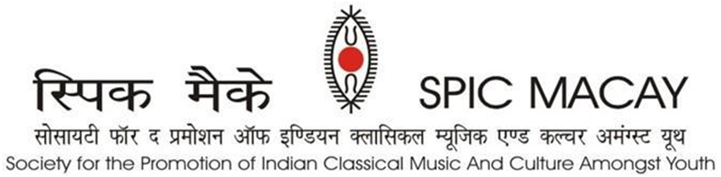

**Breath taking concerts of Ustad Shahid Parvez Khan and Pt. Venkatesh Kumar**

IITM, Chennai: The audience on Friday evening saw amazing concerts of Ustad Shahid Parvez Khan and Pt Venkatesh Kumar. The fifth day of SPIC MACAY’S 9th International Convention began at 4 am with yog (hatha and naad), soulful gurbani, followed by meditation and shramdaan.

Craft intensives -Tikuli painting (Bihar) by Shri Ashok Kumar Biswas, Gond Tribal painting (Madhya Pradesh) by Shri Bhajju Shyam, Mughal Miniature painting (Rajasthan) by Janab Shakir Ali, Roghan art (Gujarat) by Janab Abdul Gafur Khatri, Mask making (Majuli Assam) by Shri Hemchandra, Terracotta (Tamil Nadu) by Shri VK Munusamy offered opportunity to directly learn and create under guidance of renowned artists.

Various interesting intensives such as hindustani vocal, carnatic vocal, classical dance forms, puppetry, theater have been the charm of the convention. Some of the intensives comprised Kathakali by Kalamamdalam M.P.S. Namboodiri (SNA awardee), Odissi by Vidushi Madhavi Mudgal (Padma Shri Awardee), Kathak by Vidushi Sunayana Hazarilal (Padma Shri Awardee).

After morning intensives and workshops, holistic lunch followed by peaceful yog nidra, participants witnessed the play “Kanupriya”, by Dr.Ratan Thiyam. This was followed by

Music in Prayer comprising Qawwali by the Warsi Brothers from Hyderabad (SNA Awardee). Warsi brothers were accompanied by Sami Ahmed Khan, Nazeer Ahmed Khan,Aziz Ahmed Khan,Sameer Ahmed Khan,Naseer Ahmed Khan,Mohd Abdul Bari, Obaid Ahmed Khan, Muhtesham Ahmed, Syed Habbeb and Khawar Adeeb. Their pulsating music hit the hearts of audience. We heard the charming Gurbani by Dr. Alankar Singh who was accompanied by Shri Ravinder Singh, Shri Narinder Pal Singh and Shri Sandeep Singh.  He is the first and only recipient of Sangeet Natak Akademis prestigious Ustad Bismillah khan Puraskar award. His soulful rendition pleased the audience.

In the evening, Sitar performance by Ustad Shahid Parvez Khan (Padma Shri Awardee) mesmerized the audience. He was accompanied by Shri Ravindra R Yavagal (Tabla).  A beautiful concert of Hindustani classical vocal by Pt. Venkatesh Kumar (Padma Shri Awardee) accompanied by Keshav Joshi (Tabla) and Narendra L Nayak (Harmonium), left the audience enchanted. He brought out a powerful voice and a fine aesthetic feeling. The performance was mesmerizing.

This week-long international convention from 20th May to 26th May is attended by a total of 1300+ delegates and will feature 70 performances and a total of 33 intensives which include classical music, dance, yog as well as crafts by renowned maestros of our country. The main supporter of the convention is Tata Consultancy Services.

**ABOUT SPIC MACAY**

SPIC MACAY is a 45-year-old volunteer-based, apolitical, non-profit organization working to bring Indian classical music, dance and other aspects of our culture like folk arts, meditation, yoga, cinema screenings, talks by eminent persons, heritage walks and crafts workshops to university and school students. We are striving to enrich the quality of formal education among adolescents and youth by raising awareness about various aspects of Indian heritage and motivating them to imbibe the values contained therein. Volunteers from all walks of life organize about 5000 programmes every year in 100 towns of India and abroad. During the pandemic, SPIC MACAY organized 1000 programmes Online.

***Our Supporters:*** *TCS, Incredible India, Ministry of Culture, Govt. of India, Ministry of Tourism, Govt. of Uttar Pradesh, Ministry of Tourism, Govt. of Assam, NEZCC, The Hindu, Publico, DD, Times of India, DanikJagran, SRF Foundation, Ministry of Education, Govt. of India, Ministry of Culture, Govt. of India, DMI Housing Finance, Lal Family Foundation, Anand Bajaj Foundation, Turner Morrison Foundation, Takshilla, SIFF, Polaris Foundation. Individual Supporters: Yogesh Andley, Ashwini Sharma, Dinesh Vasudeva and Arun Jain.*

For more queries, please contact:

|  |  |  |
| --- | --- | --- |
| **Suman Doonga**  National Vice Chairperson  9899308093  suman.doonga@spicmacay.com | **Jayashree Kannan**  Convention Convenor  98418 16134 | **Anshuman Jain**  Media Coordinator  9810000874  anshumanjain@gmail.com |