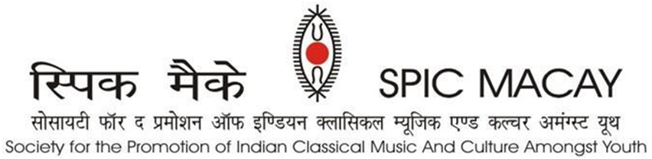

**PRESS RELEASE DAY 6 – May 25, 2024**

**Demonstration and presentation by students**

IITM, Chennai: SPIC MACAY’s 9th International Convention witnessed workshop demonstrations and presentations by the students and Gurus where they saw the hard work of the five days of intensive workshops bear fruit. The presentation sessions had students from each intensive workshop present their experiences and learnings from their Gurus.

This week-long international convention from **20th May to 26th May** was attended by a total of **1300+ delegates** and will feature **70 performances** and a total of **33 intensives** which include classical music, dance, yog as well as crafts by renowned maestros of our country. The main supporter of the convention is Tata Consultancy Services.

The Gurus also presented their experiences conducting the workshop for all 6 days as part of SPIC MACAY’s 9th international convention. The gurus of the intensive sessions were felicitated by Shri Sathyanarayana Gummadi, Professor, IITM and Shri B.S.Murthy, Director, IIT Hyderabad. Participants from Carnatic Vocal workshops conducted by Shri. Neyveli Santhanagopalan and Shri.Malladi Suri Babu said they experienced a wonderful experience under their gurus. Students from crafts art workshop like Terracota, Tikuli painting, Gond tribal art, Mask making, Mughal miniature painting and Roghan art displayed their creations. Students of Kathak, Bharatnatyam and mohiniyattam also said they were privileged to be learning from excellent gurus.

This was followed by Tamil folk dance like Karagam, Oyillatam, parai and poi kaal kuthirai, performed by team members of Chennai Kailasanathar Art Development foundation, Madhavaram. It gathered a wide range appreciation from the audience.

The evening concerts are a beautiful experience for students and music lovers from all over the country and will be attended by more than 1600 participants, where the concerts started in the evening hours at 8 PM and will go on till the early hours of sunrise. The participants are eargerly waiting to experience the performance of Padma Vibhushan Ustad Amjad Ali Khan, Padma Bhushan Vidushi Sudha Ragunathan, Vidushi Ashwini Bhide Deshpande, Shri Margi Madhu Chakyar (SNA awardee) and Padma Shri Ustad F Wasifuddin Dagar.

SPIC MACAY’s 9th International Convention will come to an end by tomorrow. On Day 7 which is the final day of the convention, the participants will go on a heritage tour to Mahabalipuram, Dakshina Chitra, Amir Mahal, Marina Beach, Mylapore, Santhome church, Egmore museum, etc.

**ABOUT SPIC MACAY**

SPIC MACAY is a 45-year-old volunteer-based, apolitical, non-profit organization working to bring Indian classical music, dance and other aspects of our culture like folk arts, meditation, yoga, cinema screenings, talks by eminent persons, heritage walks and crafts workshops to university and school students. We are striving to enrich the quality of formal education among adolescents and youth by raising awareness about various aspects of Indian heritage and motivating them to imbibe the values contained therein. Volunteers from all walks of life organize about 5000 programmes every year in 100 towns of India and abroad. During the pandemic, SPIC MACAY organized 1000 programmes Online.

***Our Supporters:*** *TCS, Incredible India, Ministry of Culture, Govt. of India, Ministry of Tourism, Govt. of Uttar Pradesh, Ministry of Tourism, Govt. of Assam, NEZCC, The Hindu, Publico, DD, Times of India, Danik Jagran, SRF Foundation, Ministry of Education, Govt. of India, Ministry of Culture, Govt. of India, DMI Housing Finance, Lal Family Foundation, Anand Bajaj Foundation, Turner Morrison Foundation, Takshilla, SIFF, Polaris Foundation. Individual Supporters: Yogesh Andley, Ashwini Sharma, Dinesh Vasudeva and Arun Jain.*

For more queries, please contact:

|  |  |  |
| --- | --- | --- |
| **Suman Doonga**  National Vice Chairperson  9899308093  suman.doonga@spicmacay.com | **Jayashree Kannan**  Convention Convenor  98418 16134 | **Anshuman Jain**  Media Coordinator  9810000874  anshumanjain@gmail.com |